1. **Situation Description**

Global Computer Solutions (GCS) company has many offices throughout the United States that require it to match highly skilled employees with projects according to both employees and customer region. In order to achieve that, we will design a database that keeps track of employees, customers, projects, and bills.

Firstly, for employees, we will store their names, hiring date, their skills, projects they are working on, and the region where they work at. Regions are divided into six different regions where each employee belongs to only one of them: Northwest, Southwest, Midwest North, Midwest South, Northeast, and Southeast. Each employee can also have one or more skill/qualification that has its own payrate and one skill/qualification can be assigned to multiple employees, as well. The company has multiple skillsets as follows: Data Entry I, Data Entry II, Systems Analyst I, Systems Analyst II, Database Designer I, Database Designer II, Cobol I, Cobol II, C++ I, C++ II, VB I, VB II, ColdFusion I, ColdFusion II, ASP I, ASP II, Oracle DBA, MS SQL Server DBA, Network Engineer I, Network Engineer II, Web Administrator, Technical Writer, and Project Manager.

In addition, each region has its own customers. For customers, we will store their names, phone number, regions they belong to, and projects they want us to implement. Each customer can have one or more projects that the company can implement. Accordingly, for each project we will store its description, estimated start and end dates, estimated budget, actual start and end dates, actual cost, date the contract was signed, customer to which it belongs, and the company’s employee who manages it. Each customer can also have one or more project that the company can work on. Besides, the actual cost of the project is updated each Friday by adding that week’s cost to total actual cost. GCS calculates every week’s cost by multiplying the hours each employee worked by the rate of pay for that employee’s skill.

Moreover, each project will have an employee with a manager skill. That person is responsible of designing and developing the project plan and splitting the project into chunks of tasks that will be performed to take the project from beginning to end. Each of these tasks will have starting and ending dates and will determine the type of skills and number of employees needed to finish that task. GCS have seven general tasks that got performed for every project as follows: the initial interview, database and system design, implementation, coding, testing, and final evaluation and sign-off.

Also, the company pools all its employees by region, then employees are assigned to a specific task scheduled by the project manager. That is, GCS searches the employees who are located in the same region as the customer, matches the skills required, and assigns the employees to the project task. Also, each project task can have many employees assigned to it, and a given employee can work on multiple project tasks. However, an employee can work on only one project task at a time. Besides, the employee cannot work on another task until the current assignment ends. The date that an assignment is closed does not necessarily match the ending date of the project schedule task because a task can be completed ahead of or behind schedule.

Furthermore, GCS keeps employee work hours in a work log that contains a record of the actual hours worked by employees on a given assignment. Each work log got filled by employees at the end of each week on Friday or at the end of each month. Each of those work logs will be linked to a specific bill number to which the work log is charged. Finally, every 15 days, a bill will be written and sent to the customer for the total hours worked on the project during that period. Also, whenever a bill is generated, GCS updates all the work logs related to that bill with the new bill number.

1. **ER Model**

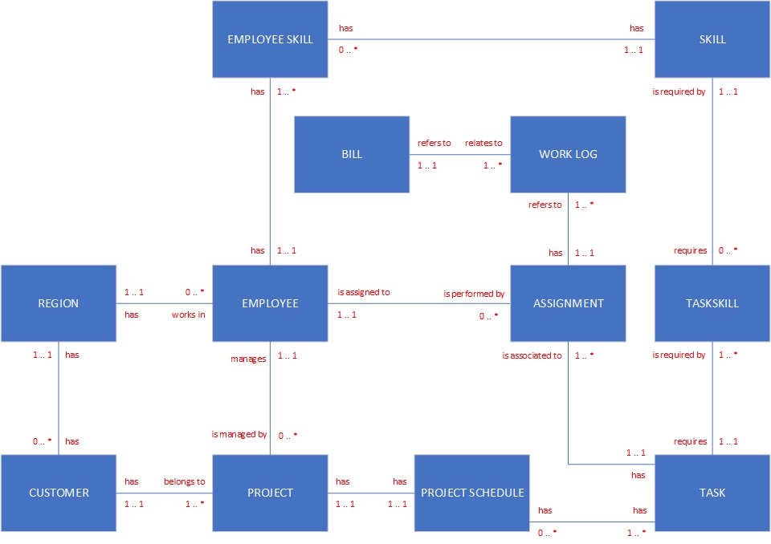

1. **Data Dictionary**

|  |  |  |  |  |  |  |
| --- | --- | --- | --- | --- | --- | --- |
| **Table Name** | **Description** |  |  |  |  |  |
| Employee | This table contains one row for each employee GCS company. |  |  |  |  |  |
|  |  |  |  |  |  |  |
| **Attribute Name** | **Attribute Description** | **PK** | **Data Type** | **Width** | **Range of Values** | **FK  Table** |
| C_EmployeeID_EP | Contains a unique value for each instance of the Employee table. | Y | I | 9 | 0-999,999,999 |  |
| T_LastName_EP | Contains the last name of each employee. | N | T | 50 | A-Z |  |
| T_MiddleInitial_EP | Contains the middle initial of each employee. | N | T | 2 | A-Z |  |
| T_FirstName_EP | Contains the first name of each employee. | N | T | 50 | A-Z |  |
| D_HireDate_EP | Contains the date of hire. | N | D | 10 | 01-01-1000, 12-31-9999 |  |
| C_RegionID_EP | Contains the foreign key from the Region table. | N | I | 6 | 0-999,999 | RG |

|  |  |  |  |  |  |  |
| --- | --- | --- | --- | --- | --- | --- |
| **Table Name** | **Description** |  |  |  |  |  |
| Region | This table contains one row for each region. |  |  |  |  |  |
|  |  |  |  |  |  |  |
| **Attribute Name** | **Attribute Description** | **PK** | **Data Type** | **Width** | **Range of Values** | **FK Table** |
| C_RegionID_RG | Contains a unique value for each instance of the Region table. | Y | I | 6 | 0-999,999 |  |
| T_RegionName_RG | Contains the name of each region. | N | T | 50 | A-Z |  |
| T_RegionCode_RG | Contains the code of each region. | N | T | 2 | A-Z |  |

|  |  |  |  |  |  |  |
| --- | --- | --- | --- | --- | --- | --- |
| **Table Name** | **Description** |  |  |  |  |  |
| Skill | This table contains one row for each skill. |  |  |  |  |  |
|  |  |  |  |  |  |  |
| **Attribute Name** | **Attribute Description** | **PK** | **Data Type** | **Width** | **Range of Values** | **FK Table** |
| C_SkillID_SK | Contains a unique value for each instance of the Skill table. | Y | I | 6 | 0-999,999 |  |
| T_SkillDescription_SK | Contains the description of each skill. | N | T | 100 | A-Z |  |
| N_PayRate_SK | Contains the rate of pay of each skill. | N | N | 9 | 0-999,999,999 |  |

|  |  |  |  |  |  |  |
| --- | --- | --- | --- | --- | --- | --- |
| **Table Name** | **Description** |  |  |  |  |  |
| EmployeeSkill | This table contains one row for each skill an employee has. |  |  |  |  |  |
|  |  |  |  |  |  |  |
| **Attribute Name** | **Attribute Description** | **PK** | **Data Type** | **Width** | **Range of Values** | **FK Table** |
| C_EmployeeID_ES | Contains the foreign key from the Employee table. | Y | I | 9 | 0-999,999,999 | EP |
| C_SkillID_ES | Contains the foreign key from the Skill table. | Y | I | 6 | 0-999,999 | SK |

|  |  |  |  |  |  |  |
| --- | --- | --- | --- | --- | --- | --- |
| **Table Name** | **Description** |  |  |  |  |  |
| Customer | This table contains one row for each customer. |  |  |  |  |  |
|  |  |  |  |  |  |  |
| **Attribute Name** | **Attribute Description** | **PK** | **Data Type** | **Width** | **Range of Values** | **FK Table** |
| C_CustomerID_CU | Contains a unique value for each instance of the Customer table. | Y | I | 9 | 0-999,999,999 |  |
| T_CustomerName_CU | Contains the name of each customer. | N | T | 200 | A-Z |  |
| T_CustomerPhoneNumber_CU | Contains the phone number of each customer. | N | T | 50 | 0-9, A-Z, -()+ |  |
| C_RegionID_CU | Contains the foreign key from the Region table. | N | I | 6 | 0-999,999 | RG |

|  |  |  |  |  |  |  |
| --- | --- | --- | --- | --- | --- | --- |
| **Table Name** | **Description** |  |  |  |  |  |
| Project | This table contains one row for each project. |  |  |  |  |  |
|  |  |  |  |  |  |  |
| **Attribute Name** | **Attribute Description** | **PK** | **Data Type** | **Width** | **Range of Values** | **FK Table** |
| C_ProjectID_PJ | Contains a unique value for each instance of the Project table. | Y | I | 6 | 0-999,999 |  |
| T_ProjectDescription_PJ | Contains the description of each project. | N | T | 400 | A-Z |  |
| D_ProjectContractDate_PJ | Contains each project's contract sign date. | N | D | 10 | 01-01-1000, 12-31-9999 |  |
| D_ProjectEstimatedStartDate_PJ | Contains the estimated start date of each project. | N | D | 10 | 01-01-1000, 12-31-9999 |  |
| D_ProjectEstimatedEndDate_PJ | Contains the estimated end date of each project. | N | D | 10 | 01-01-1000, 12-31-9999 |  |
| N_ProjectEstimatedBudget_PJ | Contains the estimated budget of each project. | N | N | 9 | 0-999,999,999 |  |
| D_ProjectActualStartDate_PJ | Contains the actual start date of each project. | N | D | 10 | 01-01-1000, 12-31-9999 |  |
| D_ProjectActualEndDate_PJ | Contains the actual end date of each project. | N | D | 10 | 01-01-1000, 12-31-9999 |  |
| N_ProjectActualCost_PJ | Contains the actual cost of each project. | N | N | 9 | 0-999,999,999 |  |
| C_CustomerID_PJ | Contains the foreign key from the Customer table. | N | I | 9 | 0-999,999,999 | CU |
| C_EmployeeID_PJ | Contains the foreign key from the Employee table. | N | I | 9 | 0-999,999,999 | EP |

|  |  |  |  |  |  |  |
| --- | --- | --- | --- | --- | --- | --- |
| **Table Name** | **Description** |  |  |  |  |  |
| Task | This table contains one row for each task. |  |  |  |  |  |
|  |  |  |  |  |  |  |
| **Attribute Name** | **Attribute Description** | **PK** | **Data Type** | **Width** | **Range of Values** | **FK Table** |
| C_TaskID_TK | Contains a unique value for each instance of the Task table. | Y | I | 9 | 0-999,999,999 |  |
| T_TaskDescription_TK | Contains the description of each task. | N | T | 400 | A-Z |  |

|  |  |  |  |  |  |  |
| --- | --- | --- | --- | --- | --- | --- |
| **Table Name** | **Description** |  |  |  |  |  |
| ProjectSchedule | This table contains one row for each task to be performed in a project. |  |  |  |  |  |
|  |  |  |  |  |  |  |
| **Attribute Name** | **Attribute Description** | **PK** | **Data Type** | **Width** | **Range of Values** | **FK Table** |
| C_ProjectID_PS | Contains the foreign key from the Project table. | Y | I | 9 | 0-999,999,999 | PJ |
| C_TaskID_PS | Contains the foreign key from the Task table. | Y | I | 9 | 0-999,999,999 | TK |
| D_TaskStartDate_TK | Contains the start date of each task. | N | D | 10 | 01-01-1000, 12-31-9999 |  |
| D_TaskEndDate_TK | Contains the end date of each task. | N | D | 10 | 01-01-1000, 12-31-9999 |  |

|  |  |  |  |  |  |  |
| --- | --- | --- | --- | --- | --- | --- |
| **Table Name** | **Description** |  |  |  |  |  |
| TaskSkill | This table contains one row for each skill that a task requires. |  |  |  |  |  |
|  |  |  |  |  |  |  |
| **Attribute Name** | **Attribute Description** | **PK** | **Data Type** | **Width** | **Range of Values** | **FK Table** |
| C_SkillID_TS | Contains the foreign key from the Skill table. | Y | I | 6 | 0-999,999 | SK |
| C_TaskID_TS | Contains the foreign key from the Task table. | Y | I | 9 | 0-999,999,999 | TK |
| I_QuantityRequired_TS | Contains the number of employees with the required skills needed to complete the task. | N | I | 3 | 0-999 |  |

|  |  |  |  |  |  |  |
| --- | --- | --- | --- | --- | --- | --- |
| **Table Name** | **Description** |  |  |  |  |  |
| Assignment | This table contains one row for each assignment. |  |  |  |  |  |
|  |  |  |  |  |  |  |
| **Attribute Name** | **Attribute Description** | **PK** | **Data Type** | **Width** | **Range of Values** | **FK Table** |
| C_AssignmentID_AS | Contains a unique value for each instance of the Assignment table. | Y | I | 9 | 0-999,999,999 |  |
| C_EmployeeID_AS | Contains the foreign key from the Employee table. | N | I | 9 | 0-999,999,999 | EP |
| C_TaskID_AS | Contains the foreign key from the Task table. | N | I | 9 | 0-999,999,999 | TK |
| D_AssignmentStartDate_AS | Contains the start date of each assignment. | N | D | 10 | 01-01-1000, 12-31-9999 |  |
| D_AssignmentEndDate_AS | Contains the end date of each assignment. | N | D | 10 | 01-01-1000, 12-31-9999 |  |

|  |  |  |  |  |  |  |
| --- | --- | --- | --- | --- | --- | --- |
| **Table Name** | **Description** |  |  |  |  |  |
| Bill | This table contains one row for each bill. |  |  |  |  |  |
|  |  |  |  |  |  |  |
| **Attribute Name** | **Attribute Description** | **PK** | **Data Type** | **Width** | **Range of Values** | **FK Table** |
| C_BillID_BL | Contains a unique value for each instance of the Bill table. | Y | I | 9 | 0-999,999,999 |  |
| N_TotalHoursWorked_BL | Contains the total hours worked for a specific period. | N | N | 3 | 0-999 |  |
| D_PeriodStartDate_BL | Contains the start date of a specific period. | N | D | 10 | 01-01-1000, 12-31-9999 |  |
| D_PeriodEndDate_BL | Contains the end date of a specific period. | N | D | 10 | 01-01-1000, 12-31-9999 |  |

|  |  |  |  |  |  |  |
| --- | --- | --- | --- | --- | --- | --- |
| **Table Name** | **Description** |  |  |  |  |  |
| WorkLog | This table contains one row for each work log. |  |  |  |  |  |
|  |  |  |  |  |  |  |
| **Attribute Name** | **Attribute Description** | **PK** | **Data Type** | **Width** | **Range of Values** | **FK Table** |
| C_WorkLogID_WL | Contains a unique value for each instance of the WorkLog table. | Y | I | 9 | 0-999,999,999 |  |
| N_HoursWorked_WL | Contains the actual hours worked by employee on a given assignment. | N | N | 3 | 0-999 |  |
| D_WeekEndingDate_WL | Contains the last workday of the month or current Friday of the month. | N | D | 10 | 01-01-1000, 12-31-9999 |  |
| C_AssignmentID_WL | Contains the foreign key from the Assignment table. | N | I | 9 | 0-999,999,999 | AS |
| C_BillID_WL | Contains the foreign key from the Bill table. | N | I | 9 | 0-999,999,999 | BL |